How do I Change my Address with USCIS?

If you applied for an immigration benefit with the U.S. immigration agency (known as USCIS, for “U.S. Citizenship and Immigration Services”), you are supposed to update your address with USCIS within 10 days of moving. If you were represented by an attorney or accredited representative and they no longer represent you in your case with USCIS, you should also make sure to update your address with USCIS so that you do not miss any important correspondence about your case.

These are the steps you can take to make sure you update your address correctly and safely with USCIS.

Step 1: Confirm what kind of case you have with USCIS by looking at your receipt or requesting your file from USCIS, also called making a Freedom of Information Act (or “FOIA”) request.

Step 2: Follow USCIS’s instructions for address updates for your type of case & learn about your rights around address confidentiality.

Step 3: Keep careful records and keep checking on your case for updates.

Step 4: Consider talking with a trusted attorney or accredited representative.

- Confirm what type of application or applications you have with USCIS.

- USCIS receives and considers many types of cases or applications. To find out what type of case or application you have with USCIS, look for a “receipt notice” (known as Form I-797) from USCIS. USCIS would have sent it to you (or, if you were represented at the time the application was filed, to your attorney/representative).

- The receipt notices from USCIS look like this:

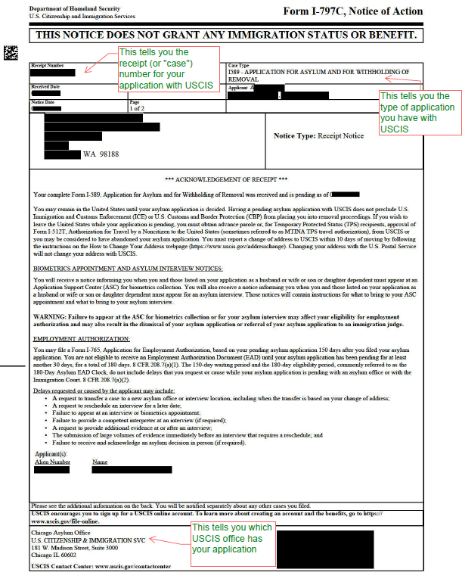

- The receipt notice tells you the type of application you have pending with USCIS and which USCIS office has the application.

  - NOTE: You may have more than one kind of application with USCIS. You should have a receipt notice for each individual application.

What if I don’t have my receipt notice? Or any documents about my case at all?

- If you don’t have a copy of anything that was submitted to USCIS and don’t know what was filed in your name, you still have options. You can complete a “FOIA request” with USCIS to find out what applications in your name are pending before USCIS. A FOIA request is a request to a government agency to receive information that that agency has about you. Here is where you can find information about FOIA requests to USCIS: https://www.uscis.gov/records/request-records-through-the-freedom-of-information-act-or-privacy-act

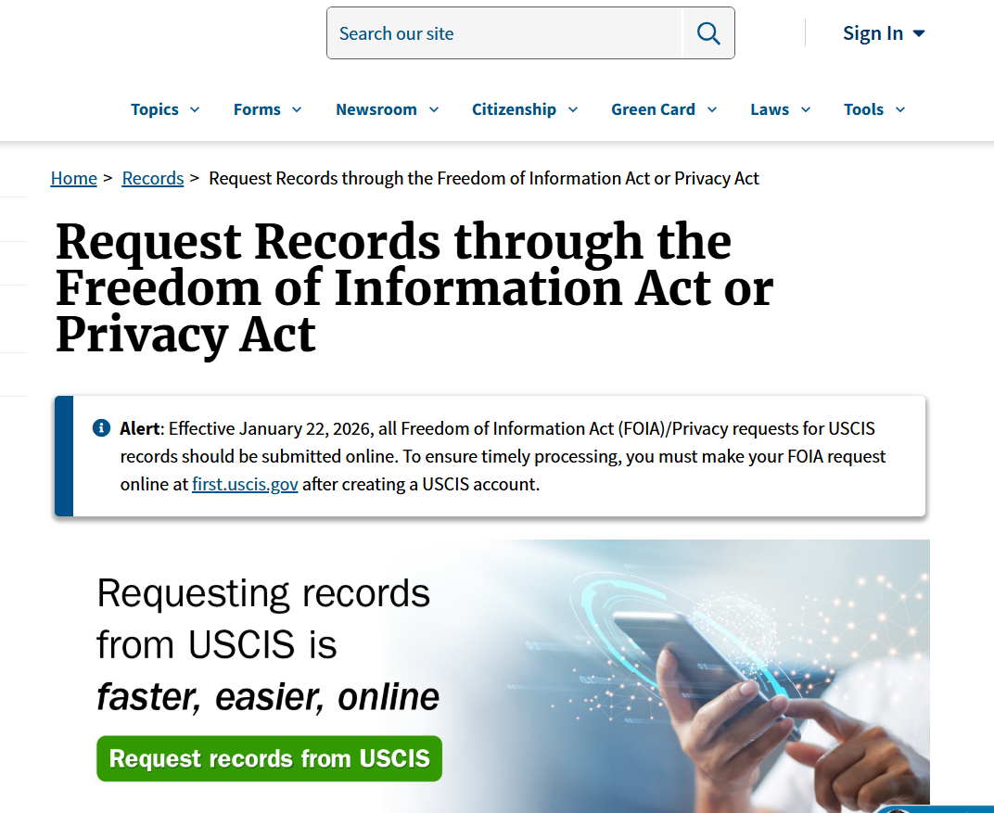

  - NOTE: FOIA requests to USCIS require that you provide a physical and mailing address. A physical address is the address where you actually live. A mailing address is an address where you feel comfortable receiving your mail. Your physical and mailing addresses can be the same or they can be two different addresses. USCIS may already have this information about you from your originally filed application. But not everyone will have given their physical address to USCIS before. If you did not share (or are not sure whether you shared) your physical address with USCIS previously, it is something to be aware of. If you disclose your physical address to the government when you file the FOIA, then the government will have it. If you are concerned about this, you should speak with a trusted immigration attorney. More resources on this below.

- Once you know the type of application you have with USCIS, you can update your address following the instructions USCIS has for your type of application.

- There are different rules for different types of applications, so it is important to follow the rules for your type of application.

  - NOTE: If you have more than one application pending with USCIS, you should note each type of application and the receipt number for each pending application in your communication to USCIS regarding your change of address.

- The general instructions from USCIS for changes of address can be found here: https://www.uscis.gov/addresschange. They include instructions for updating your address online with a myUSCIS account or by mailing Form AR-11. This form is available here: https://www.uscis.gov/sites/default/files/document/forms/ar-11.pdf/

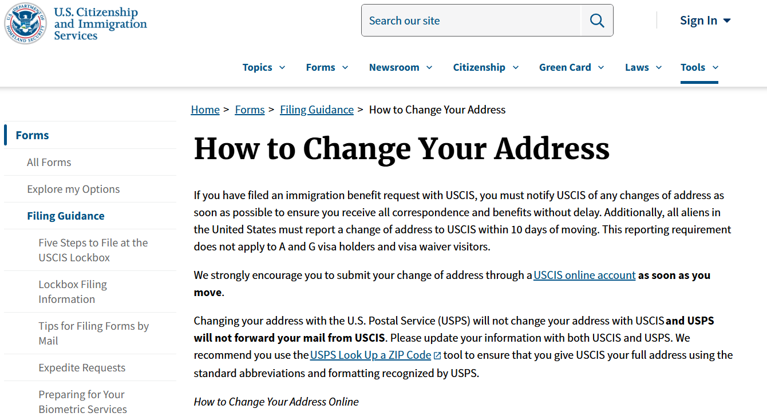

  - NOTE: The AR-11 form requires that you provide a physical and mailing address. USCIS may already have this information from your originally filed application. But if your physical address was not previously disclosed, then the government will now have your physical address if you submit it with the AR-11. If you are concerned about this, you should speak with a trusted immigration attorney. More resources on this below.

- **USCIS has special instructions for changing an address on applications that relate to domestic violence, trafficking, or other crimes.** The special instructions can be found here: https://www.uscis.gov/forms/filing-guidance/how-to-change-your-address/change-of-address-procedures-for-vawatu-cases-and-form-i-751-abuse-waivers

  - NOTE: For these types of cases, you cannot update your address online. You can send a paper change of address form, Form AR-11, to the specific USCIS office that has your application. You can also call the USCIS Customer Service Line, 800-375-5283, to update your address that way. For either option, you will need the receipt number of your application to complete the process.

  - NOTE: For these types of cases, there are special protections that mean you should not have to provide your physical address on the Form AR-11. If you are filling this form out, you can write “Confidential 8 USC 1367” in the space provided for your physical address. This note tells USCIS that your physical address is confidential information protected under a special law. However, it is possible that USCIS rejects your form if you do this. Unfortunately there is a lot of uncertainty around what USCIS will do in these special situations. If you are concerned about this, you should speak with a trusted immigration attorney. More resources on this below.

- Keep careful records and keep checking on your case for updates.

- The address update process can take a long time. Sometimes it can take eighteen months or more to process an address change. USCIS will normally send you an updated receipt notice with the correct address when the address update has been carried out.

  - NOTE: USCIS may continue to mail notices about your application or case to an old or out of date address, even after receiving and processing a change of address form.

- Keep proof and copies of how and when you updated your addresses with USCIS. At a future point, USCIS may attempt to send mail to you. The mail could be important and request more information for your application to continue being processed, or inform you of an important appointment. If you do not receive this mail, you will not be able to respond to the request from USCIS and your application will be denied. Having proof that you correctly updated your address, or copies of documents that show you tried to update your address would be very helpful in this type of situation. It would help you appeal against a denial or to convince USCIS that your case should be reopened.

- If you like, you can check the status of your application(s) using the receipt number that is on the receipt notice. You can do this by calling the USCIS Customer Service Hotline, 800-375-5283 or online at https://egov.uscis.gov/. You can also make an account with USCIS at: https://my.uscis.gov/.

  - NOTE: For some types of applications (particularly those that relate to domestic violence, trafficking, or other serious crimes), you will not be able to get a status update online - for those you will have to call the USCIS Customer Service Hotline, 800-375-5283.

- Finally, it is important to know that if an application is denied for any reason, the applicant has the right to file a request to USCIS to reopen or reconsider the negative decision if they have new evidence. The applicant can also appeal the denial to the Administrative Appeals Office. An individual in that situation should consult with an attorney to learn more about their options. If someone’s case is denied and they do not request reopening/reconsideration or appeal, they will likely be summoned for a deportation proceeding in immigration court. If an individual has shared their most recent physical address with the government the government may use their address to locate and arrest them.

- Should I be consulting an immigration attorney or accredited representative for advice?

- It may make sense to consult with a trusted and experienced representative before you submit anything to USCIS. They can help you understand the different important considerations for your case. For example, an attorney or representative can talk to you about:
- Whether you must disclose your physical address or if you are in a special situation which can allow you to keep your physical address confidential.
- Strategies for updating your address in ways that keep you as safe as possible.
- Help you to understand what, if any, risks are involved with disclosing or not disclosing certain information to USCIS, or in waiting to obtain more information through a FOIA request.

- Speaking with a trusted attorney is also highly recommended if you are worried that you have been the victim of fraud or malpractice by a former attorney or representative. A trusted attorney or representative can review your case documents to help you confirm if you were the victim of any harmful practice and how to protect yourself from the possible impacts.

  - NOTE: USCIS can initiate a deportation case in immigration court against someone whose application they have denied. So, anyone who has a fraudulent or baseless application pending with USCIS could come to be in this situation.

- If you are able to retain an attorney quickly, the attorney would take charge of your case and notify USCIS that they represent you. The attorney would then receive all correspondence relating to your case.

Where can I find trusted attorneys or accredited representatives?

- You can contact NWIRP’s offices:
  - Tacoma: 253-235-9279, TSUintake@nwirp.org
  - Granger: 509-854-2100, grangerintake@nwirp.org
  - Wenatchee: 509-570-0054, wenatcheeintake@nwirp.org
  - Seattle: 206-587-4009, seattlefrontdesk@nwirp.org

- You can call the private immigration attorneys listed here: www.ailalawyer.com
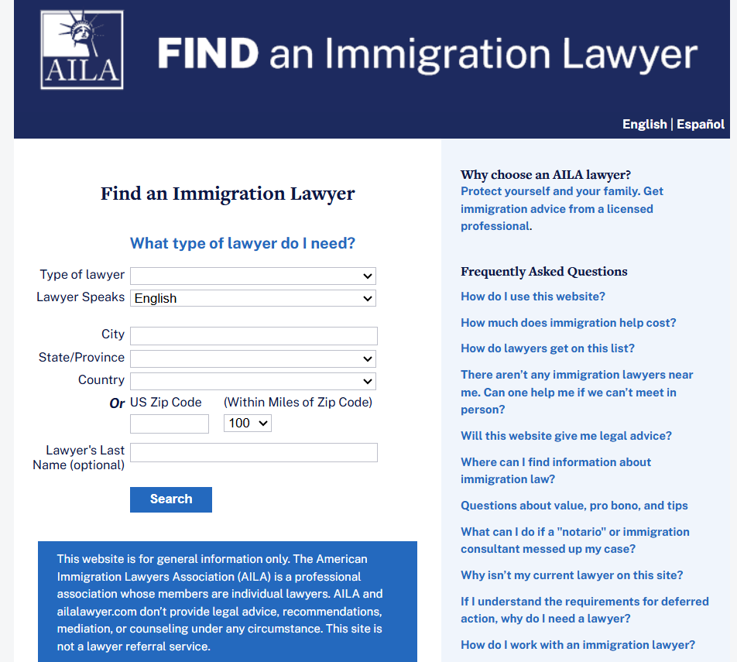

How do I Change my Address with the Immigration Court or the Board of Immigration Appeals?

If you have an immigration court case or an appeal before the Board of Immigration Appeals (BIA), you are supposed to update your address with them within 5 working days of any change to your contact information. If you were represented by an attorney or accredited representative and they no longer represent you in your case, they should communicate with the immigration court or the BIA about this change in representation. However, you should also make sure that your address is updated with the court or the BIA, so that you do not miss any important notices about your case.

These are the steps you can take to make sure you update your address correctly with the Immigration Court or the Board of Immigration Appeals.

Step 1: Confirm where your case is currently being processed by looking up your case information system online or by telephone.

Step 2: Provide your updated mailing address to the Court or the BIA using the correct form. You must provide an exact copy of this form to the ICE attorney. You should also keep a copy for your own records.

Step 3: Keep careful records and keep checking on your case for updates.

Step 4: Consider talking with a trusted attorney or accredited representative.

- Confirm where your case is being processed.

- You can check where your case is currently being processed online by visiting https://acis.eoir.justice.gov/es/. You can also check by telephone calling, 1-800-898-7180. You will need your A# (a number that begins with A and is followed by 8 or 9 digits, often found on your immigration documents) to check on the location, date, and time of your next immigration court hearing.

- If your case is on appeal to the Board of Immigration Appeals (BIA), you can also get information about your appeal at the same website and phone number shared above.

- Send in your change of address form to the Court or BIA, plus a copy to the ICE attorney.

- Once you’ve completed the step above to confirm the location of the immigration court that is reviewing your case, you can send the change of address form, form EOIR-33/IC, to that court. A copy of the form must also be sent to the ICE attorney’s office located in the same city as the immigration court. This is the link to the form EOIR-33/IC: https://www.justice.gov/eoir/media/1341856/dl?inline.

  - NOTE: You can find the mailing address for the ICE attorney’s office that serves the immigration court where your case is pending by searching here: https://www.ice.gov/contact/field-offices?office=12

- If your case is with the Board of Immigration Appeals (BIA), then you must send a different change of address form, Form EOIR-33/BIA, to the BIA. A copy of the form must also be sent to the ICE attorney’s office located in the city where your last immigration court hearing took place. A copy of the form can be found here:
https://www.justice.gov/eoir/media/1341901/dl?inline. The mailing address of the BIA is:

Executive Office for Immigration Review
Board of Immigration Appeals
Clerk’s Office
5107 Leesburg Pike, Suite 2000
Falls Church, VA 22041

- Keep careful records and keep checking on your case status for updates.

- The Court or the BIA sometimes make mistakes and may continue to mail notices about your case to an old or out of date address, even after receiving and processing a change of address form.

- Keep proof and copies of how and when you updated your addresses with the immigration court or the BIA. One way to do this is by using registered mail or a mail courier service that provides proof of delivery, like FedEx or UPS. That way, if important case information is not mailed to you at your updated address, you will have proof that the problem was not your fault. Having proof that you correctly updated your address, or copies of documents that show you tried to update your address would be very helpful in case you ever miss an important case notice, like a notice about a hearing date. Missing a hearing in immigration court usually leads to a deportation order, so it is best to try to avoid missing hearings or other case notices.

- To be extra safe, you can check the status of your case online or by phone. You can check where your case is currently being processed online by visiting https://acis.eoir.justice.gov/es/. You can also check by telephone calling, 1-800-898-7180. You will need your A# (a number that begins with A and is followed by 8 or 9 digits, often found on your immigration documents) to check on the location, date, and time of your next immigration court hearing.

- Should I be consulting an immigration attorney or accredited representative for advice?

- Speaking with a trusted attorney is always helpful. It is especially recommended if you are worried that you have been the victim of fraud or malpractice by a former attorney or representative. A trusted attorney or representative can review your case documents to help you confirm if you were the victim of any harmful practice and how to protect yourself from the possible impacts.

- If you are able to retain an attorney quickly, the attorney would take charge of your case and notify the immigration court or the BIA that they represent you. The attorney would then receive all correspondence relating to your case.

Where can I find trusted attorneys or accredited representatives?

- You can contact NWIRP’s offices:
  - Tacoma: 253-235-9279, TSUintake@nwirp.org
  - Granger: 509-854-2100, grangerintake@nwirp.org
  - Wenatchee: 509-570-0054, wenatcheeintake@nwirp.org
  - Seattle: 206-587-4009, seattlefrontdesk@nwirp.org

- You can call the private immigration attorneys listed here: www.ailalawyer.com

